November 2022 Breakfast Menu
~Milk is served with all meals~
Monday | Tuesday | Wednesday | Thursday | Friday
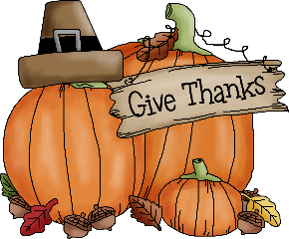 | 1  Scooby Snacks®*  Yogurt  Dried Cranberries  100% Juice | 2  Mini Pancakes*  Syrup  Grapes & Cantaloupe  100% Juice | 3  Biscuit* & Gravy  Strawberries & Pineapple  100% Juice | 4  Breakfast Pizza*  Orange Wedges  100% Juice
7  Assorted Cereal Bars*  Yogurt  Peaches  100% Juice | 8  Long John*  Strawberries  100% Juice | 9  Frudel®*  Pineapple Melon Salad  100% Juice | 10  Omelet  Toast*  Banana  100% Juice | 11  Mini Cinnis®*  Apple Slices  100% Juice
14  Assorted Cereal Bowls*  Toast*  Raisins  100% Juice | 15  Sausage & Egg Bagel*  Pears  100% Juice | 16  UBR®*  Apple Slices  100% Juice | 17  French Toast Bites*  Syrup  Yogurt  Banana  100% Juice | 18  Ring Donut*  Mandarin Oranges  100% Juice
21  Assorted Cereal Bowls*  Toast*  Orange Wedges  100% Juice | 22  Breakfast Pizza*  Applesauce  100% Juice | 23  Assorted Donuts* (Long John, Ring Donut)  Assorted Fruit  100% Juice | 24  No School | 25  No School
28  No School | 29  Pop Tarts®*  Yogurt  Mixed Fruit  100% Juice | 30  Power Bites®  Toast*  Assorted Fruit  100% Juice | This institution is an equal opportunity provider. | This menu is subject to change without notice.
Breakfast Prices: Elementary Students=$1.50, Middle & High School Students=$1.75, Adults=$2.00
Questions? Contact Julie Miller, Food Service Supervisor:millerj@newton.k12.ia.us OR 641.792.5797, ext. 2001.

